Chill Out and Read!
PARP Week 2020

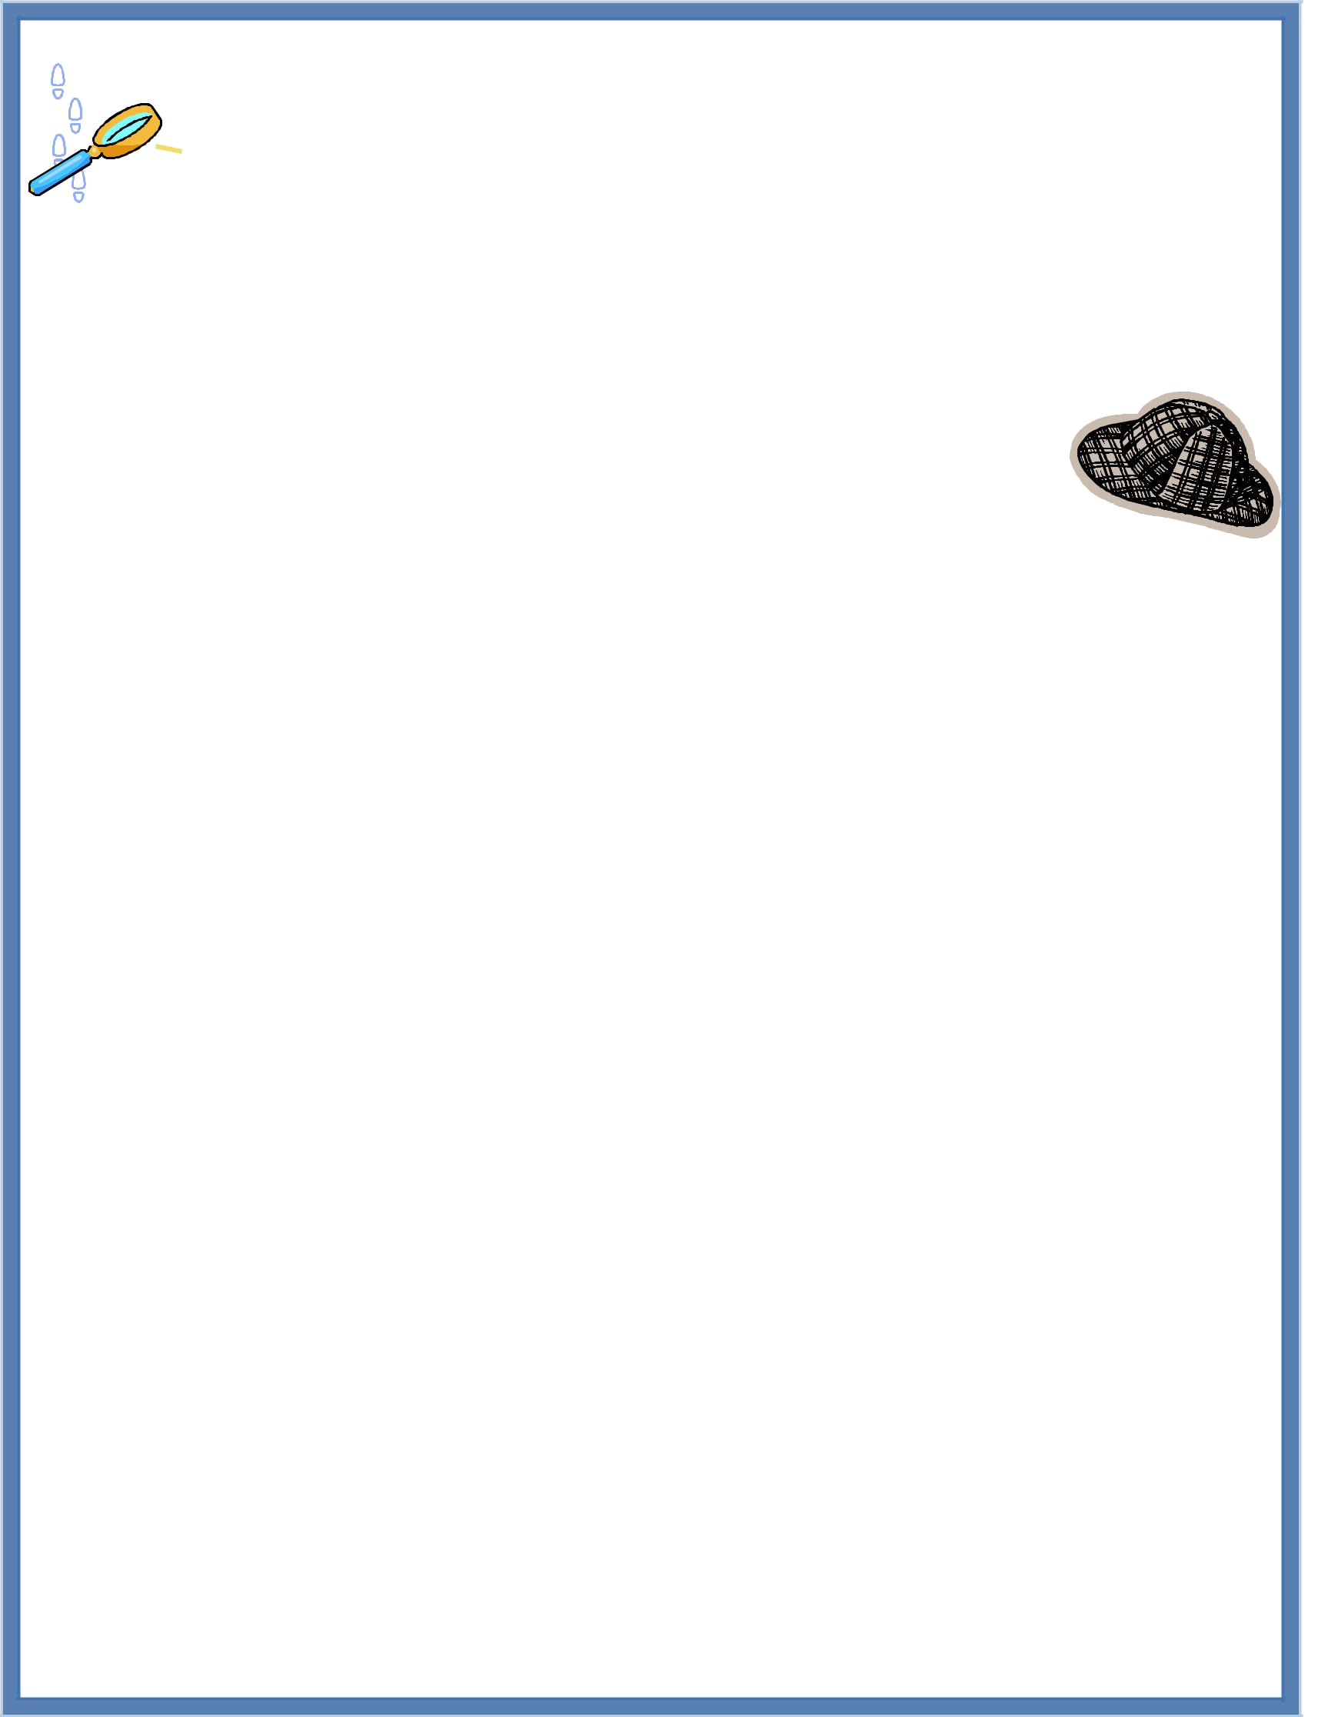
Mystery Reader
Since you are a "mystery" to the students, I am hoping you will be willing to write five clues about yourself that I can give to the class as hints before you come.

Here is a sample set of clues for you to refer to:

1. I love to watch the Octonauts with my son.

2. My favorite vacation spot is the beach.
3. I have a 4 year old son and a 9 years old daughter.

4. I am originally from Venezuela.
5. My family has a dog named Blue.

I start with clue #1 and end with clue #5. As you get closer to clue #5, you should make your clues a bit more revealing so that your child starts to recognize some of the information in the clues. It is so fun when students realize that their parent is the one who has written the clues and will soon be reading to our class!

Please let me know if you have any questions!

Clue 1: _______________________________________________

_____________________________________________________

Clue 2: _______________________________________________
_____________________________________________________

Clue 3: _______________________________________________
_____________________________________________________

Clue 4: _______________________________________________

_____________________________________________________

Clue 5: _______________________________________________

_____________________________________________________

